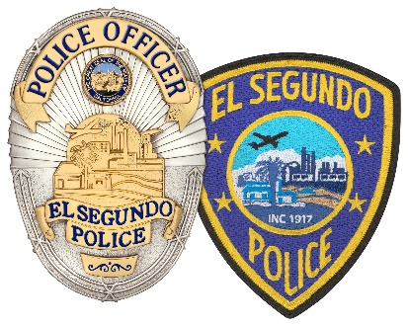
EL SEGUNDO
POLICE DEPARTMENT
348 MAIN STREET, EL SEGUNDO, CA 90245
(310) 524-2200

SAUL RODRIGUEZ, CHIEF OF POLICE

Press Release

FOR IMMEDIATE RELEASE February 19, 2025

Suspect Arrested in Domestic Disturbance Incident

On February 17th, at approximately 6:00 AM, the El Segundo Police Department responded to a domestic disturbance in the 300 block of Penn Street. A mother and son (suspect) were involved in a physical altercation during which the mother was assaulted with a knife. She was in critical condition and was transported to the hospital, where she was stabilized, treated, and subsequently released.

The suspect refused to exit the residence. The El Segundo Police Department deployed its Crisis Negotiation Team; however, the suspect continued to refuse compliance. Following this, the El Segundo SWAT Team deployed tactical measures to compel the suspect to exit the residence. He eventually complied and was taken into custody without further incident.

The case will be presented to the LA County District Attorney's Office at the Los Angeles Airport Courthouse, where charges of attempted murder will be filed.

The El Segundo Police Department would like to thank the community for its support during this critical incident. We would also like to express our gratitude for the mutual aid provided by the El Segundo Fire Department, Los Angeles Airport Police Department, Hawthorne Police Department, Manhattan Beach Police Department, Hermosa Beach Police Department, Culver City Police Department, Redondo Beach Police Department, and the Gardena Police Department.

For all media inquiries, please contact Lieutenant Michael Sistoni at msistoni@elsegundo.org or 310-524-2254.

