Content-width banner (Tall):
- Example Page: https://www.destinationelsegundo.com/food-drinks/all-restaurants-bars
- Template Name: Basic Page or Landing Page w/Image and Facilities Map
- Rules:
  - Requires both Image Random and Image Rotate widgets, stacked on top of each other
  - Widget order does not matter
  - Bottom widget must be used:
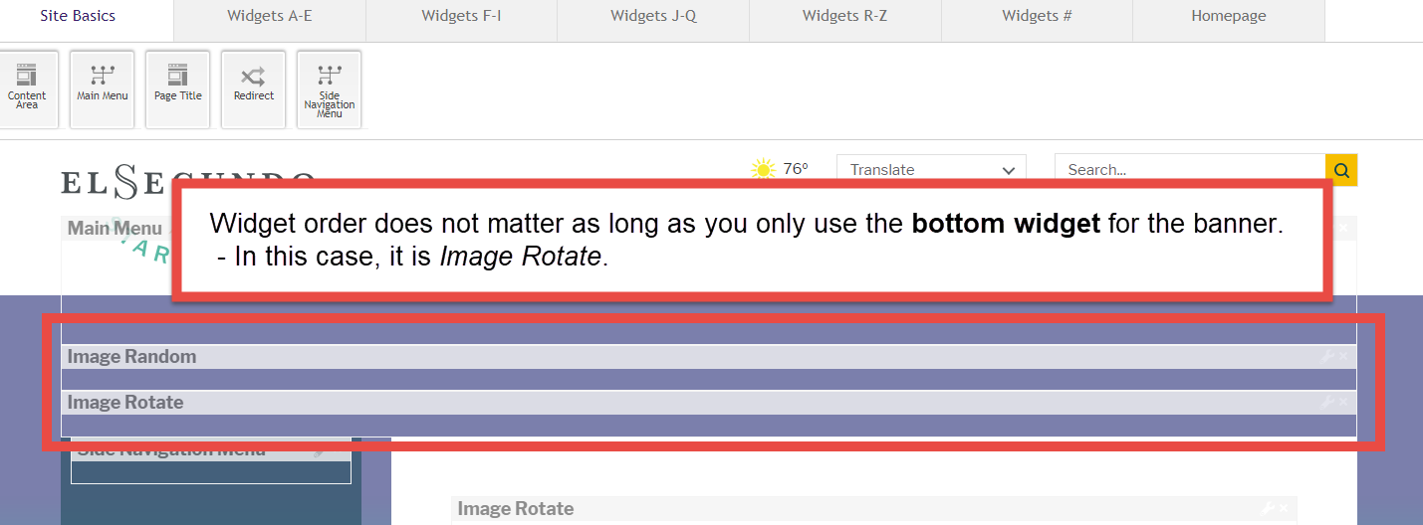

Content-width banner (Short):
- Test Page: https://www.destinationelsegundo.com/about/tourism-advanced-components/content-width-banner-page-short
- Page Template: Basic Page with Content-width Banner (Short)
- Ideal Dimensions: 1302 x 200 pixels
- Rules:
  - Requires either the Image Random and Image Rotate widgets
  - Only one widget can be used

Full-width banner
- Test Page: https://www.destinationelsegundo.com/about/tourism-advanced-components/full-width-banner-page
- Page Template: Basic Page with Full-width Banner
- Rules:
  - Requires the Interior Collage Full Width widget

