Your training session may have been conducted on one of your sites Dev or Staging or Live
- To login, type your web address domain into a web browser and add (/admin)
  - EXAMPLE- http://stagec10.visioninternet.net/Admin/
  - Use your username and password
- The CMS Basic Training session consists of these three objectives: Client will have
  - Ability to Navigate and Locate content on the CMS
  - Ability to Edit, Build, Save and Publish content within your Content Group
  - Ability to Organize content in the components so the content flows to the front-end widgets
- The Basic Agenda:
  - Dashboard and administration interface overview
  - Support Menu and Help buttons
  - Intro and overview of Homepage
  - Interior page overview
  - Site Content tab
    - Pages
      - How to find pages in the back end of the CMS
      - Adding, editing and deleting
      - Saving, Archiving and Publishing
    - Image Library- How to Upload
    - Document Central- How to Upload
    - Calendar- Overview of the component and how to Create an Event
    - News- Overview of the component and how to Create a News Story
  - Review of Concepts / Discussion

Reminders:
- Google Chrome is the preferred browser to use while editing content in the CMS
- “Site Preview” shows a functional “Preview of what your content would look like if it is in Published mode”
- To get a site visitor/user experience: Log out, or use an “Incognito” tab in Chrome: ctrl + shift + N
- A Basic User can edit content built by and for other users in their Content Group
- A Super User can build and edit content for any Content Group
- If you delete something, Super Users can restore it by locating it in the Trash
- The Image Library and Document Central are NOT filing cabinets
- Upload documents in a way that your site visitors would understand (folder, names, key words)
- When building content in many components -> Check in the “Show all options” purple banner for more settings
- In the settings tab, assign Tags – Categories, Departments that push your content to the correct pages
(keep in mind: widgets, eNotifications)
- A Super User can modify an existing page by dropping a new Widget within the Page Layout
  - When added an orange box briefly appears, hover over it immediately and “Rename the Page Template” or you will have many Page Templates called Basic Page (copy) in your Page Templates section
- Use the Help button, Support Tab, CMS Videos, Online Reference and http://help.visioninternet.com/ before reaching out to Support@granicus.com

Glossary of Terms:

Approval Cycle | The CMS allows a user to create or edit content, then pass it to another user for approval before it’s published or live on the site. Once approved, it goes live. Approvals can be done in one step (that is, a content contributor can create or edit a piece of content and then also directly publish to show up on the front of the website) or in 2 or more steps. Workflow is part of the Approval Cycle, meaning a piece of edited content can also be rejected by an approver preventing the content from being published.
Category | Most content types (Calendar, News, etc.) can have its own set of categories, which can be created by a user with the proper permissions, and then can be applied to individual pieces of content (event, News article, etc.) for several purposes. Categories factor into 1) widget filters (constraints) and 2) which subscription lists receive certain eNotifications.
Component | A section of the CMS designed to manage each CONTENT TYPE respectively, such as Pages, Images, Documents, News, Events, Directories, Jobs, RFPs, and so on. When you want to add an event to a page, you must build the event in the Calendar Component under the Site Content drop down in the back end of the site.
Content Group | Every piece of content is built within a Content Group. This indicates which group of CMS users have oversight permissions, to edit, delete etc. Each Content Group can have a specified Workflow/Approval Cycle for publishing content too. Content Groups are generally a department title that designates what group of users can edit this content. Users can be built to have access to a single content group, or multiple, but a piece of content (a page, event, or news article) can only belong to a single Content Group.
Content Review | Most items of content can be given a review date (the Parks and Recreation Pool page must be reviewed 1x a year for updates to the monthly schedule) when a review date is applied the CMS will notify the designated user, within the CMS and optionally through email.
Content Type | For example: Pages, Images, Documents, News, Events, Jobs, RFPs, and so on.
Department | Often misused, this is a tag feature for filtering purposes. The department tags are universal across components unlike a Category tag which is specific to an individual component.
eNotifications | Site visitors can subscribe to email notifications for news, events, job posts, and RFPs based on available categories. After content is published a 15-30-minute period to make edits or cancel before automated distribution (emails sent). If it is January and you are publishing an event that will happen in March, the CMS will send the eNotification automatically 6 days in advance of said event unless scheduled otherwise.
Layout | The designated amount of sections to a page. These are options for building a new Page Template: One Column, Reverse Two Columns, Three Columns, Three Equal Columns, Two Columns, or Two Equal Columns. The Layout of a Page can’t be changed.
Locked Content | A piece of content remains locked to a CMS user until it is sent forward in the Approval Cycle/ Publishing process. This prevents multiple users from opening a piece of content simultaneously. The content can be unlocked by either a Super User or the most recent editor of the content (the user it is locked to).
Main Navigation | The main menu consists of pages built and managed within the Pages component. If your CMS has an “Advanced Mega Menu” it is possible to nest various widgets in the Menu drop down.
Publish/Expire Date | Any item of content can be automatically published to or expired from the front end of the site, based on dates assigned. Published date is when it goes live, expired is when it is removed from the front end and available only to CMS users.
Side Navigation | A box widget often placed on the left side of a page which displays the navigation name of other pages and subpages in the same menu.
Page Template | Each Page Template is used to build 1 or more Pages in the CMS. A CMS User with the proper Security Role or a Super User is able to Edit an existing or build a new Page Template in 2 different ways. There will be a number of default page template options CMS Users can use to build a new page. Page Templates are available to users based upon content group, and this access can be adjusted by editing the individual Page Template. The best Practice way of adjusting Page Templates is in the Configurations > Page Templates component.
Widget | Sections on the pages of the website contain various content blocks called widgets. These content blocks, or widgets, pull information from components in the back-end of the website to display it on the front-end website. They can be set to include specific posts. When creating or editing Page Templates, you will be able to create a custom combination of widgets to display different types of content, organized on the same page. Then that template is available for use throughout the site. Each site widget serves a different purpose and function, and many of them provide numerous settings that will customize the look and function to meet an individual need. To make changes to what is displayed in a widget you must > Edit the page where the Widget Exists > Select the White Wrench of the widget > Adjust the settings > Save and Publish.
Workflow | Set of steps or states (Workflow States) that are applied to a piece of content. These are linear steps that must be completed in order, and all steps must be completed for the content to go live on the website. As the content makes its way through the steps, it may be approved to go forward, or it may be rejected backwards to an earlier step.

Image Scaling – Use .jpg or .png
Use desktop photo editor application to SCALE images BEFORE uploading to Image Library
Content Area Widget | 200-500px width – Consider the purpose of the picture  *** When adding image to the Content Area- use % of Content Area instead of PX size***
Page Banner,  Image Widget | One column page layout: 1024px width  Two column page layout: 500-900px width  Aspect ratio is flexible so decide and crop before uploading.
Photo Album | Minimum 640px width by 480px height; Maximum 1024x768px  Aspect ratio: 4x3
Thumbnails,  visionSocial (optional)  Customize text in the message composer, title and subtitle sections as well as switching to a new image. | Facebook  Large image dimensions – 600 x 315  Small image dimensions – 120 x 120  "Invalid Image" dimensions – less than 120 x 120  Twitter  Large image dimensions:280 x 150  Small image dimensions:120 x 120  "Invalid Image" dimensions: less than 120 x 120
Home Collage/Hero Image and | 1920px wide, height and width depend on your design
Other Specific Need | If photos are meant to be viewed full size or downloaded, scale accordingly

Steps to build a responsive and compliant data table:
1 | Insert the table and add data; you may need to work with the generated table to adjust size
2 | Right-click any cell and open Table Properties
3 | On lower left column, for css class, on the dropdown menu, select: TableData
4 | - Click “Accessibility” tab, type number of heading row(s) and/or column(s);  - If necessary; Add a Caption about the table;  - Verify that “Associate cells with headers” box at bottom is selected;  - Click OK

Web Content Accessibility Guidelines (WCAG 2.0 AA)
- Your CMS framework is WCAG compliant, it is up to YOU to maintain compliant content
- The top 5 things that will cause your site to depreciate in a compliance spectrum:
  - Heading Styles
    - Use the proper order
  - Lists- Number Lists and Bullet Lists
    - Do not copy and paste lists from Word into your website
  - Data Tables
    - Build using the steps outlined above
  - Links
    - Link text should be the subject of where you will go or what you will do when you click the link
    - ALL DOCUMENTS AND THE CONTENT THEY CONTAIN MUST ALSO BE COMPLIANT
  - Images
    - Use Alternative Text (ALT Tag) A short description of what is occurring in the image
    - Icons/images with text- must have an accurate description of the text within the Alt Tag
- For examples, guidelines and updated information visit: https://www.w3.org/WAI/standards-guidelines/wcag/

Using the Basic Page Template and editing the Content Area Widget
- Most Basic Page Templates have 3 sections and 4 widgets built into it:
    - Main Menu
    - Side Navigation
    - Page Title
    - Content Area
 | - To change the content in a widget, click on wrench icon on right end of its title bar.  *Note: if the wrench is gray, the widget cannot be altered.  **Note: If you don’t see the widgets, make sure you are in “Edit mode.” You may need to click  (at the top, if on front end) or 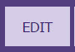 (on purple bar, if on “Review mode” from back end)  - If it’s a Content Area widget, you will be able to enter text, images, links, etc. with the design text editor.  You can also toggle to HTML if you need to place an embed code on the page.  - If not a Content Area widget, there will be a variety of settings to customize which posts come from the components.
  Main Menu widget
    Side navigation widget
    Page Title widget
    Content area widget
- Beyond the Basic Page Template, if you want another type of content on your page, such as: news; events; job posts; an eNotifications sign-up; photo albums; or any of the other components (i.e. Dashboard > Site Content > ), you can add a widget for any of those, BUT you have to use another template, NOT Basic Template. (You can swap templates later.) The other templates come with everything on the Basic + a widget for another component. For example: You want a photo album on your page… A Photo Album Template has all the basics widgets + Photo Album widget. If you want to further customize the combination of widgets on your page, you may need to build a Page Template to include those widgets you want; and swap your page or create your page with that template.

Image Properties
For specifications about scaling images before uploading, refer to “Reference Guide: Image Scaling.”
This guide explains:
- How to add an image to through the Image Library shortcut on the Toolbar of the Editor Tool;
- How to use Image Properties to change the way the appearance and layout of the image.
You can adjust image display settings, such as dimensions, border, alignment, padding (space around it), border (optional), alt tag/text, etc.
Note: Thumbnails are designated from a separate selection field, not from within the Editor Tool.
- The Editor Tool is in one of two places, depending on the component / content type:
- Pages component — open the Content Area widget (white wrench) to access the Editor Tool
- Other components — the Details area is the Editor Tool.
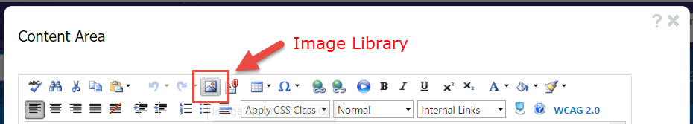
- Note: wherever your cursor is placed in the Editor Tool is where the image will be placed.
On the Toolbar, there is an icon called “Image Library.” It opens a box called Image Manager.
This is a shortcut to the folders and files contained in the Image Library component.
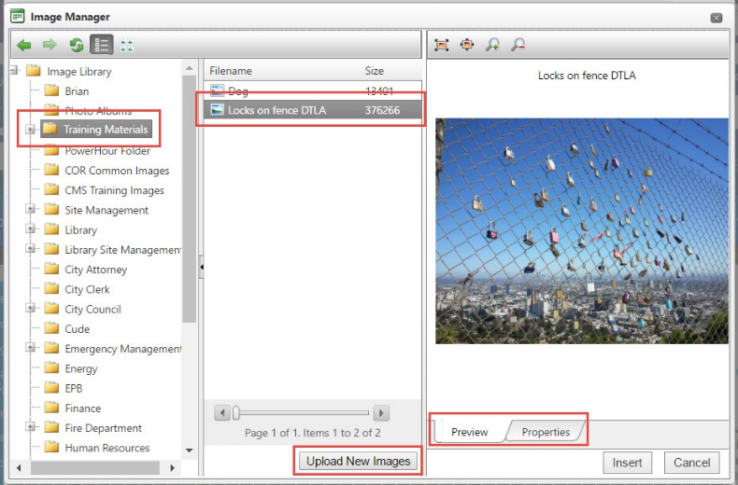
- On the left column, select the corresponding folder for your image.
- In the middle column, select the desired image already stored in that folder. If your image isn’t there, you can directly upload an image from your computer to that folder, by clicking Upload New Images.
- On the right column, there is a Preview of the image. (Sometimes browser variables cause this column to be blank. There’s a workaround ahead on step 7.) If it is not blank, you can also switch the tab from Preview to Properties, where you can adjust the image immediately (details are below), or you can access the Image Properties as described in step 7.
- When you click Insert, the image will be shown within the Editor Tool.
- To access the Image Properties and adjust the image appearance, right-click on the image.
[Right-click means use the right – not left – mouse button to click.]
The Properties… are:
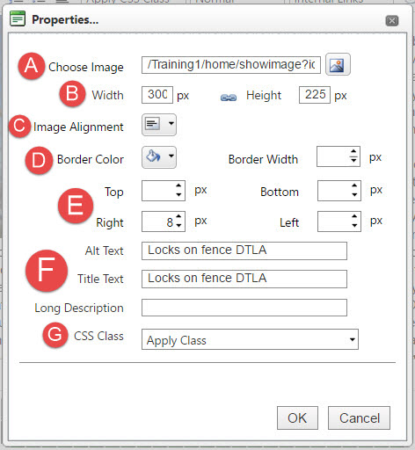
- Choose Image – shows folder path within which image is contained in Image Library. If you need a different image, do not use this Image Library icon. Instead, cancel and delete this image, and start over, because changing the path here could force the properties as written to apply improperly to newly chosen image.
- Width and Height – set width size in % of Content Area space. Chain-link icon represents locking / retaining dimensions ratio. Using px will distort Image in mobile view
- Image Alignment – click the box containing the tiny triangle to reveal and select from the five options for alignment. Text will automatically wrap around the image on the opposite sides of its alignment.
- Border Color, Border Width – options to build and display a border around the image. If you want a border, the width must be > 0px to display.
- Top, Bottom, Right, Left – refers to the padding of negative space between image and text.
- Alt Text – must be set for content accessibility. If the image has words in it - the words must be in the Alt Text as well. The Alt Text should be a short description of the image.
- Title Text – aka Tool Tip- not necessary for WCAG compliance
- Long Description – additional details indexed into search engine algorithms for search results. not necessary for WCAG compliance
- CSS Class – pre-set design styles can be applied for specific page elements. Generally, there is no need to apply a CSS Class on the image properties.

Swap Page Template

- Find your page. Click in the yellow. On the Action Menu, select Edit Page Design.
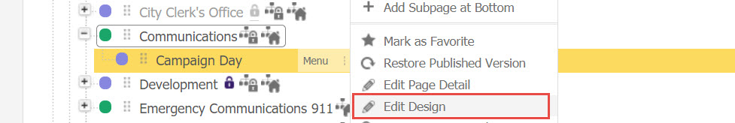
- Open the Content Area widget – by clicking the white wrench.
- Toggle the editor view from DESIGN to HTML.
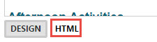
- Copy the entire HTML text. So as not to rely on the Clipboard (text recently copied and stored)… Paste into a plain text editor, like Windows Notepad. – NOT Microsoft Word, as it adds formatting.
It’s smart to save the .txt file, too, in case your computer shuts down spontaneously.
- Save or don’t. Return to the Pages component. Find your page. Click in the yellow.
On the Action Menu, select Swap Page Template.
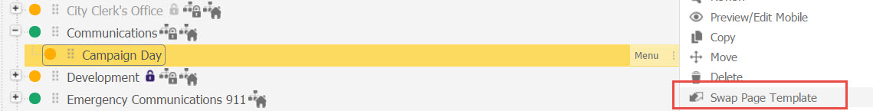
A reminder message appears:
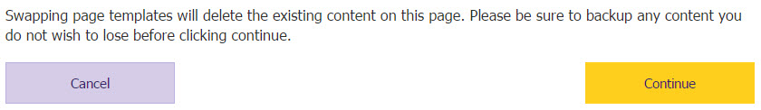
If you saved the HTML text, click Continue.

- Choose the Page Template you want. Click Save.
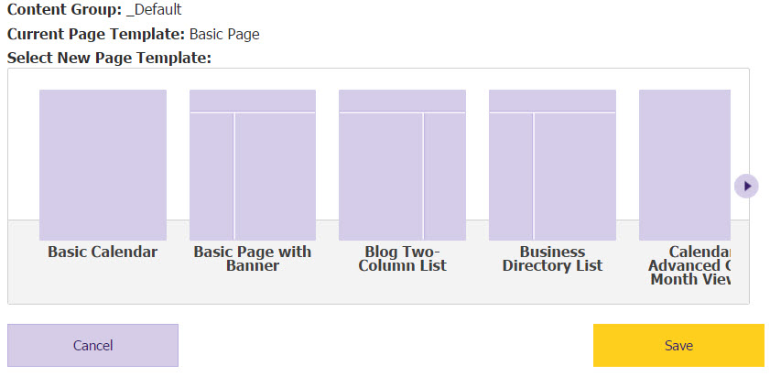
- On the Action Menu, select Edit Page Design.
- Open the Content Area widget – by clicking the white wrench.
- Toggle the editor view from DESIGN to HTML.
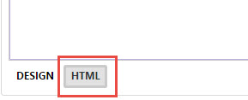
- Paste the copied HTML text into the text editor. Click Save.
- Complete your page. As available, click Save, Save & Approve, or Save & Publish.

List of Components

All Components have corresponding widgets. CMS User access and abilities to these Components is based upon Content Groups, Workflows, Content Roles and Security Roles. Most of this is taken care in the building blocks of your site/custom built by your PM.

Found in the Site Content drop down. Some will NOT be available for ALL clients

- Pages
- Image Library
- Document Central
- Calendar
- News
- Business Directory
- Enotifications
- Facility Directory
- FAQs
- Forms
- Forms and Surveys
- Job Posts/ Application Manager (not available for all Clients)
- Online Payments (not available for all Clients)
- Online Polls
- Photo Album
- RFP Post
- RSS Feeds
- Service Directory
- Service Requests
- Social Media
- Staff Directory

List of Widgets

Some of these Widgets will NOT be available for ALL clients

Site Basics- All widgets exist on the Basic Page Template already (no need for the Redirect)
- Content Area
- Main Menu
- Page Title
- Redirect- Not necessary to add to a Page Template- Redirect already exists as an option in Page Details
- Side Navigation Menu

Widgets A-E
- Accordion
- Blog Archives- Only Available if you have visionPulse
- Blog Related Posts- Only Available if you have visionPulse
- Blog Two-Column List- Only Available if you have visionPulse
- Business Directory Box
- Business Directory List
- Calendar Advanced Grid- Can display events with a color scheme if Categories have set colors
- Calendar Box
- Calendar Grid
- Calendar List
- Calendar Meeting List
- Calendar Mini Grid
- Calendar Tile
- Content Filter Widget- Accessory widget for searching within other widgets added to Page Template
- Custom Content- Useful for building own custom design- Advanced Users
- Document Folder
- Document Folder Box
- Document List
- Document List Box
- eNotification-Could be a Standalone widget on a page or an “Accessory” widget added to a page displaying Events, News, RFPs or Job Posts

Widgets F-I
- Facebook Feed
- Facility Directory Formatted List
- Facility Directory Multi Select Categories Map
- Facility Directory Standard Map
- Facility Directory Table List
- FAQ Box
- FAQ List
- Form Builder Detail- Display a single Form built in the Forms Component
- Form Builder List- Displays a List of Forms built in the Forms Component
- Form Detail- Display a single Form/Survey built in the Forms and Surveys Component (could be named Surveys)
- Form List- Displays a List of Forms and Surveys built in the Forms and Surveys Component (could be named Surveys)
- Full Width Banner- Display Images at the top of your interior pages
- Image Random
- Image Rotate
- Interior Collage with Captions
- Interior Image Buttons
- Interior Page Spotlight

Widgets J-Q
- Job Applicants- Only available for clients with Application Manager
- Job Posts Box
- Job Posts List
- Meeting Archiver- Only available for clients with Meetings Manager
- Meeting Box- Only available for clients with Meetings Manager
- Meeting Items Box- Only available for clients with Meetings Manager
- Meeting Items List- Only available for clients with Meetings Manager
- Member Login Bar (For AD Only)- often already applied to a custom page built by your PM
- News Box
- News List
- News Tiles
- Online Polls Details- Displays a single Poll built in the Polls component
- Online Polls List- Displays a list of Polls
- Photo Album
- Photo Album List

Widgets R-Z
- Recent Topics- Only Available if you have visionPulse
- RFP Post Box
- RFP Post List
- RSS Feed List View
- RSS Feed Viewer
- Search- A standalone widget. Unnecessary to add to a new page template- search should already be set up by your PM
- Service Directory Box
- Service Directory List
- Service Request- A standalone widget. Unnecessary to add to a new page template
- Site Map- A standalone widget. Unnecessary to add to a new page template
- Staff Directory Box
- Staff Directory List
- Tabbed Widget
- Tag Cloud Widget- often only Available if you have visionPulse
- Topic Grid- Only Available if you have visionPulse
- Twitter Feed
- Vision Search-
- Vision Search Home Widget-
- Website Login Bar- Member Group access point
- Yahoo Weather Javascript Widget

