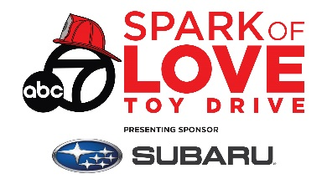
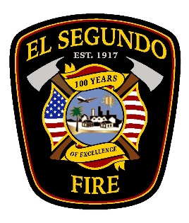
El Segundo Fire Department
“Spark of Love”
TOY DRIVE

Only organizations serving the City of El Segundo and Surrounding South Bay Cities will be accepted, and they must submit a copy of their non-profit status (501(C)3). The ESFD does its best to fulfill all requests, but please know that toys cannot be guaranteed to each request. Toy requests will be accepted on a first come, first served basis.
DATE:
AGENCY NAME:
FEDERAL TAX ID #:
CONTACT:
PHONE:
EMAIL ADDRESS:
AGENCY ADDRESS:
When will your toys be distributed? Give a brief description of the procedure you will follow for toy distribution, including date, time, and location (if possible):

 | FILL IN THE TOTAL NUMBER OF CHILDREN IN EACH AGE GROUP BELOW. USE ACCURATE NUMBER. DO NOT OVER ESTIMATE.
AGE | INFANT  1 day-12 mos | 12-24 mos. | 2-3 |  | 4-6 | 7-8 | 10-12 | 13-15 |  | 16-18 | TOTAL
BOYS
GIRLS

Legal Disclosure:
Happy Holidays! Thank you for participating in the Spark of Love Toy Drive. We are undertaking efforts to clean these toys, but please note that there are limits as to what can be done during a global pandemic. By participating in this event, and in exchange for your participation, you agree to assume all risks of contracting Covid-19 here, unless we have been negligent. For your safety, upon receipt please be sure to also do your own secondary cleaning of your gift.

Print Name: __ _________________________________

Signature: ____________________________________ Date: ___________________

Submit this form via email to SparkOfLove@elsegundo.org.

