
INFORMATION BULLETIN/CALGREEN CODE
Electrical Vehicle (EV) Charging for Residential Buildings

The California Green Code (CALGreen) sets requirements for installing Electric Vehicle (EV) capable infrastructure in new residential and nonresidential buildings. CALGreen contains minimum requirements that apply state-wide.
The new construction of single-family residences, duplexes (Two-Family Dwelling), and townhouses with private garages must have raceway and panel capacity to support future installation of Level 2 charging stations. These residential EV infrastructure aligns with the state policies, including Assembly Bill (AB) 2565 and AB 1796. The AB 1796 empowers renters to deploy EVSE on the properties where they reside by reducing the practical barriers for them to do so.
This Information Bulletin provides a summary of the CALGreen requirements for the Electric Vehicle (EV) charging for new construction of residential projects as follows:
- New Single-Family Dwelling with attached garage
- New Two-Family Dwelling with attached garage
- New Multi-Family Dwellings with less than 20 dwelling
- New Single-Family Dwelling with 20 or more dwelling units
- New Hotels and Motels with less than sleeping units or guest rooms
- New Single-Family Dwelling with 20 or more sleeping units or guest rooms
This Information Bulletin also includes the CALGreen requirements for additions and alterations of parking facilities serving existing multi-family buildings.

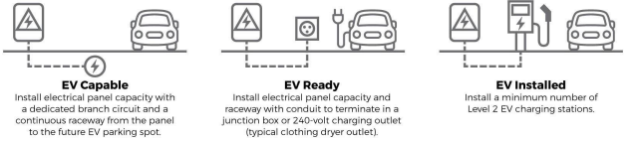
DEFINTIONS:
ACCESSIBILITY. [DSA-AC & HCD 1-AC] The combination of various elements in a building, facility, site or area, or portion thereof which allows access, circulation and the full use of the building and facilities by persons with disabilities in compliance with this code.
ACCESSIBLE. [DSA-AC & HCD 1-AC] A site, building, facility, or portion thereof that is approachable and usable by persons with disabilities in compliance with this code.
ACCESSIBLE ROUTE. [DSA-AC & HCD 1-AC] A continuous unobstructed path connecting accessible elements and spaces of an accessible site, building or facility that can be negotiated by a person with a disability using a wheelchair, and that is also safe for and usable by persons with other disabilities. Interior accessible routes may include corridors, hallways, floors, ramps, elevators and lifts. Exterior accessible routes may include parking access aisles, curb ramps, crosswalks at vehicular ways, walks, ramps and lifts.
ELECTRIC VEHICLE (EV). An automotive-type vehicle for on-road use, such as passenger automobiles, buses, trucks, vans, neighborhood electric vehicles, electric motorcycles and the like, primarily powered by an electric motor that draws current from a rechargeable storage battery, fuel cell, photovoltaic array or other source of electric current. Plug-in hybrid electric vehicles (PHEV) are considered electric vehicles. For purposes of the California Electrical Code, off-road, self-propelled electric vehicles, such as industrial trucks, hoists, lifts, transports, golf carts, airline ground support equipment, tractors, boats and the like, are not included.
ELECTRIC VEHICLE (EV) CAPABLE SPACE. A vehicle space with electrical panel space and load capacity to support a branch circuit and necessary raceways, both underground and/or surface mounted, to support EV charging.
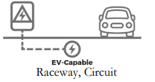
ELECTRIC VEHICLE (EV) CHARGER. Off-board charging equipment used to charge an electric vehicle.
ELECTRIC VEHICLE (EV) READY SPACE. [HCD] A vehicle space which is provided with a branch circuit; any necessary raceways, both underground and/or surface mounted; to accommodate EV charging, terminating in a receptacle or a charger.
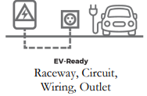
ELECTRIC VEHICLE CHARGING SPACE (EV SPACE). A space intended for future installation of EV charging equipment and charging of electric vehicles.
ELECTRIC VEHICLE CHARGING STATION (EVCS). One or more electric vehicle charging spaces served by electric vehicle charger(s) or other charging equipment allowing charging of electric vehicles. Electric vehicle charging stations are not considered parking spaces.
ELECTRIC VEHICLE SUPPLY EQUIPMENT (EVSE). The conductors, including the ungrounded, grounded and equipment grounding conductors and the electric vehicle connectors, attachment plugs, and all other fittings, devices, power outlets or apparatus installed specifically for the purpose of transferring energy between the premises wiring and the electric vehicle.
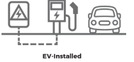
LEVEL 2 ELECTRIC VEHICLE SUPPLY EQUIPMENT (EVSE). [HCD] The 208/240-volt 40-ampere branch circuit, and the electric vehicle charging connectors, attachment plugs and all other fittings, devices, power outlets or apparatus installed specifically for the purpose of transferring energy between the premises wiring and the electric vehicle.
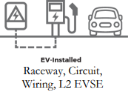
NEIGHBORHOOD ELECTRIC VEHICLE (NEV). A motor vehicle that meets the definition of "low-speed vehicle" either in Section 385.5 of the Vehicle Code or in 49 CFR571.500 (as it existed on July 1, 2000) and is certified to zero-emission vehicle standards.
TOWNHOUSE. A single-family dwelling unit constructed in a group of three or more attached units in which each unit extends from the foundation to roof and with open space on at least two sides.
ZEV. Any vehicle certified to zero-emission standards.
EV Requirements- Residential Mandatory Measures per Chapter 4 of California Green Code (CALGreen).
Accessory Dwelling Units (ADU)
No Electric Vehicle (EV) charging is required when no additional parking spaces are required for the proposed ADU.
Junior Accessory Dwelling Units (JADU)
No Electric Vehicle (EV) charging is required when no additional parking spaces are required for the proposed JADU.
New Single-family Dwelling with Attached Private Garage
Install a listed raceway to accommodate a dedicated 208/240-volt 40-amper branch circuit with a branch circuit overcurrent protective device.
Two-Family Dwelling with Attached Private Garage
Install a listed raceway to accommodate a dedicated 208/240-volt 40-amper branch circuit with a branch circuit overcurrent protective device.
Townhouses with Attached Private Garage
Install a listed raceway to accommodate a dedicated 208/240-volt 40-amper branch circuit with a branch circuit overcurrent protective device.
Multifamily Development Projects with less than 20 dwelling units
- 10% of total number of parking spaces on the building site shall be EV Capable
- 25% of total number of parking spaces on the building site shall be EV Ready
- EV Capable Spaces shall support future Level 2 EVSE
- EV Rady spaces shall be equipped with low power Level 2 EV Charging receptacles. Only one receptacle per each dwelling unit is required
- Area of parking facilities served by parking lifts are exempt from providing EV Ready spaces
Multifamily Development Projects with than 20 or more dwelling units
- 10% of total number of parking spaces on the building site shall be EV Capable
- 25% of total number of parking spaces on the building site shall be EV Ready
- EV Capable Spaces shall support future Level 2 EVSE
- EV Rady spaces shall be equipped with low power Level 2 EV Charging receptacles. Only one receptacle per each dwelling unit is required
- 5% of total number of parking spaces on the building site shall be equipped with Level 2 EVSE. Automatic Load Management System (ALMS) may be used to reduce the maximum required electrical capacity when low power Level 2 EV charging receptacle or Level 2 EVSE are installed beyond the minimum required EV Chargers
- Area of parking facilities served by parking lifts are exempt from providing EV Ready spaces
Hotels and Motels Projects with less than 20 Sleeping Units or Guest Rooms
- 10% of total number of parking spaces on the building site shall be EV Capable
- 25% of total number of parking spaces on the building site shall be EV Ready
- EV Capable Spaces shall support future Level 2 EVSE
- EV Rady spaces shall be equipped with low power Level 2 EV Charging receptacles. Only one receptacle per each dwelling unit is required
- Area of parking facilities served by parking lifts are exempt from providing EV Ready spaces

Hotels and Motels Projects with 20 Sleeping Units or Guest Rooms or More
- 10% of total number of parking spaces on the building site shall be EV Capable
- 25% of total number of parking spaces on the building site shall be EV Ready
- EV Capable Spaces shall support future Level 2 EVSE
- EV Rady spaces shall be equipped with low power Level 2 EV Charging receptacles. Only one receptacle per each dwelling unit is required
- 5% of total number of parking spaces on the building site shall be equipped with Level 2 EVSE. Automatic Load Management System (ALMS) may be used to reduce the maximum required electrical capacity when low power Level 2 EV charging receptacle or Level 2 EVSE are installed beyond the minimum required EV Chargers
- Area of parking facilities served by parking lifts are exempt from providing EV Ready spaces

Electric Vehicle Charging Stations (EVCS) Dimensions
- Minimum length of 18 feet
- Minimum width of 9 feet
- Minimum of 8 feet wide aisle is required for each 25 charging stations, but not less than one
  - Minimum 5 feet wide aisle provided with 12 feet wide EV space is acceptable in lieu of 8 feet wide aisle
  - Minimum aisle for

- Surface slope of EV space shall not exceed 1:48 (1 unit vertical in 48 unit horizontal) slope in any direction serving public accommodations, public housing, motels, and hotels shall comply with Chapter 11B of Building Code
Accessible EV Spaces
- All EVSE for hotels and motels, when installed, shall comply with Chapter 11B of Building Code for EV chargers
- EV Ready Spaces and EVCS in multifamily development shall comply with Chapter 11A, Section 1109A, of Building Code
- EVCS serving public accommodations, public housing, motels, and hotels shall comply with Chapter 11B of Building Code
EVCS Location
- EVCS space shall be located adjacent to an accessible parking space meeting the requirements of Chapter 11A of Building Code to allow us of EV charger from the accessible parking space
- EVCS space shall be located on accessible route
- EVCS serving public accommodations, public housing, motels, and hotels shall comply with Chapter 11B of Building Cod
EV Space Requirements
- Listed raceway capable of accommodating a 208/240- volt dedicated branch circuit
- Raceway shall not be less than trade size 1 (nominal 1-inch inside diameter)
- Raceway shall originate at the main service or subpanel and shall terminate into a listed cabinet, box, or enclosure in close proximity to the location or the proposed location of EV space
- Service panel or subpanel shall have a 40-ampere minimum dedicated branch circuit, including branch circuit overcurrent protective device installed, or space(s) reserved to permit installation of a branch circuit overcurrent protective device
EV for Additions and Alterations of Parking Facilities serving Existing Multi-Family Dwellings
When new parking facilities are added, or electrical systems or lighting of existing parking facilities are added or altered and the work requires a building permit, ten (10) percent of the total number of parking spaces added or altered shall be electric vehicle charging spaces (EV spaces) capable of supporting future Level 2 EVSE.
SIGNAGE
Electric vehicle ready spaces shall be identified by signage or pavement markings in compliance with Caltrans Traffic Operations Policy Directive 13-01 (Zero Emission Vehicle Signs and Pavements markings).
Processing of Permit Applications to install Electric Vehicle Charging Stations
In compliance with Assembly Bill (AB) 970 (2021), the permit application to install Electric Vehicle Charging Station(s) will be processed and reviewed within 10 working days from the time the application and the supporting documents are submitted to the city to Permits@ElSegundo.org.

Required Documents:
- Completed Building Permit Application
- Site Plans showing the location of the proposed EVCSs
- Plans to show compliance with Accessibility requirements per Chapter 11A or 11B as applicable
- Provide parking analysis on the plans showing the number of the required and provided parking spaces
- Floor plan showing the location of the proposed EVCSs when installed inside a building
- Completed “Checklist for Permitting Electric Vehicles and Electric Vehicle Service Equipment (EVSE) for Residential and Nonresidential Buildings”
- Electrical Plans

Resources:
- Electric Vehicle Charging Station Permitting Guidebook
https://static.business.ca.gov/wp-content/uploads/2019/12/GoBIZ-EVCharging-Guidebook.pdf
- Assembly Bill (AB) 1236 (2015)
https://leginfo.legislature.ca.gov/faces/billNavClient.xhtml?bill_id=201520160AB1236
- Assembly Bill (AB) 970 (2021)
https://leginfo.legislature.ca.gov/faces/billNavClient.xhtml?bill_id=202120220AB970
- California Permitting Electric Vehicle Charging Stations: Best Practices
https://business.ca.gov/industries/zero-emission-vehicles/plug-in-readiness/permitting-electric-vehicle-charging-stations-best-practices/
- Sothern California Edison (SCE)
https://www.sce.com/residential/ev-overview
- Accessibility and Signage for Plug-In Electric Vehicle Charging Infrastructure
https://www.calbo.org/sites/main/files/file-attachments/ca_accessibility_for_ev_charging.pdf?1524861081
- Building Permit Application
https://www.elsegundo.org/home/showdocument?id=2857&t=638036651038172110

Sample EVCS Layouts
Figure 1: Two EVCS = one van accessible EV space required
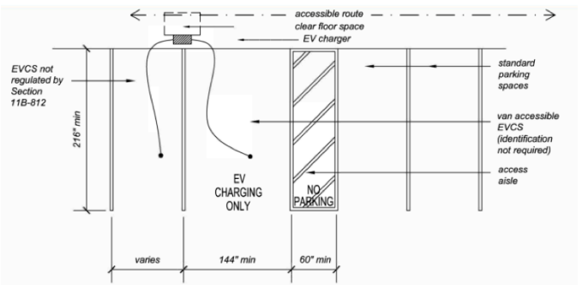
Figure 2: Five EVCS = two accessible EV spaces required
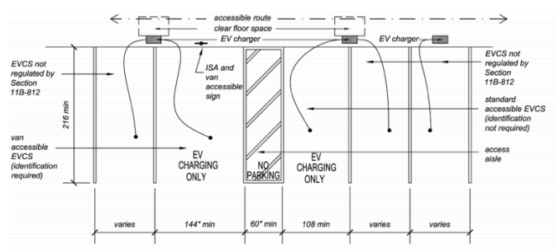
Figure 3: 26 EVCS = three accessible EV Spaces required
