EL SEGUNDO CIVIC CENTER PLAZA LOCATION

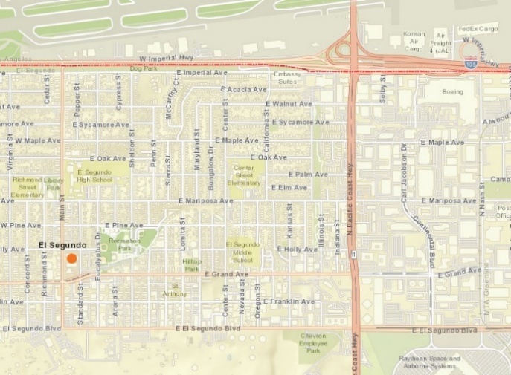
Civic Center Plaza
on Main St. south of Holly Ave. Parking on Main St., Holly Ave., and Standard St.

105 Freeway

Pacific Coast Highway
Imperial Highway

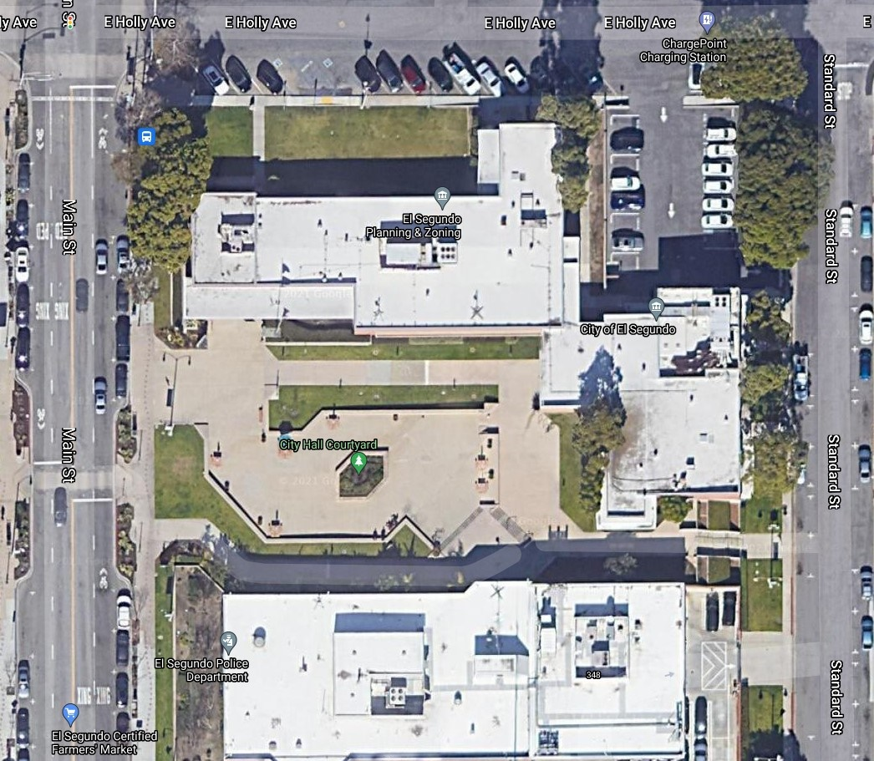
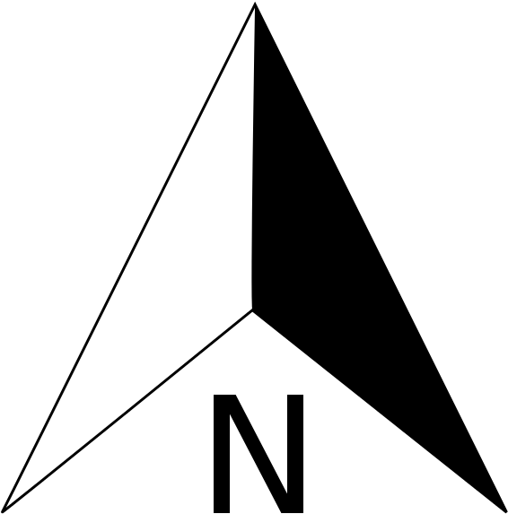
Civic Center Plaza

